Fugitive Dust Permit Report
Jordan M. Couture

Summary: Applicability:
Fugitive dust is defined as particulate matter that is generated or emitted from open air operations e.g. did not pass thought a vent or stack. Particulate matter >10 microns is of particular concern to environmental and human health. A 1990 amendment to the clean air act set a mandate that states set up a permitting process to regulate fugitive dust in compliance with federal standards.

Permit Name
Federally: Title 5 “Part 70 permits”/ Title 1
Alaska: Standard Operating Permit Condition X – Reasonable Precautions to Prevent Fugitive

APPLICABILITY
The potential to emit fugitive dust alone does not trigger the need for a permit.
>100 tons per year of a specific pollutant Major Permit
15-99 tons per year Minor Permit

Operations that require a permit
- Asphalt plants (at least 5 tons per hour)
- Thermal soil remediation units (at least 5 tons per hour)
- Rock crushers (at least 5 tons per hour)
- Incinerators (at least 1,000 tons per hour)
- Coal preparation plants
- Port of Anchorage stationary sources

PROCESSING TIMES
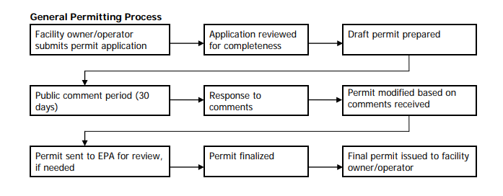
Takes anywhere from several months to several years depending on the complexity of the permits
Agency Coordination:
Federal Oversite: EPA
Lead Agency State: Alaska DEC Air Quality Division
Director: Alice Edwards
Consultation Process
Determine if you fall under Title I or Title V regulations
Aaron Simpson
907-465-5123
or
Patrick Dunn
907-269-7582

Determine what type of permit you need

ADEC Air Quality Permit Intake Clerk
Yesenia Camarena
Phone: 907-269-3070

Information Necessary:
What does the agency need from you?
Sample Permit PDF included as separate document, Checklist included in this document.
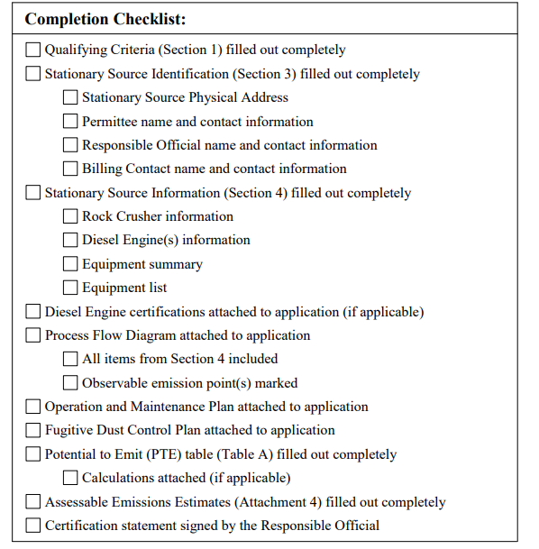
Who/How do you get that information?
Speak with you site engineers and project managers to discuss the scope of the project and discuses viable options. Work with state regulators on what they consider reasonable. Review previously approved permits.
Example Documentation:
- See included rock crusher permit
Special definitions:
Reasonable precautions:
As defined by the Alaska DEC “Reasonable precautions are measures to prevent particulate matter from being emitted into the air. Examples include spraying down material with liquid, installing enclosures around areas from which emissions come, and discontinuing operation under unfavorable weather events such as high winds. When required, DEC works with operators to determine what reasonable precautions are needed to maintain air quality standards. ”
Enforcement and Penalties:
REGULATIONS (CFR)
State:
18 AAC 50.X) Covers Air Quality Control
(18 AAC 50.045), “a person who causes or permits bulk material to be handled, transported, or stored, or who engages in an industrial activity or construction project shall take reasonable precautions to prevent particulate matter from being emitted into the ambient air.”
18 AAC 50.110 Air pollution prohibited: No person may permit any emission which is injurious to human health or welfare, animal or plant life, or property, or which would unreasonably interfere with the enjoyment of life or property.
18 AAC 50.346. Construction and operating permits: Standard Operating Permit Condition X – Reasonable Precautions to Prevent Fugitive

Federal:
Title V “Part 70 Permits” of the Clean Air Act adopted in 1990 which requires the Environmental Protection Agency (EPA) to establish a national, operating permit program
Title 40 of the Code of Federal Regulations, Chapter 1, Part 70 (Part 70)] which require states and local permitting authorities to develop and submit federally enforceable operating permit programs for EPA approval
40 CFR § 63.X defines that standards state and local permitting programs must meet
EPA's Federal Air Rules for Reservations Farr Covers Reservations (40 CFR Part 49, Section 126)
Title I Permits cover emissions during construction

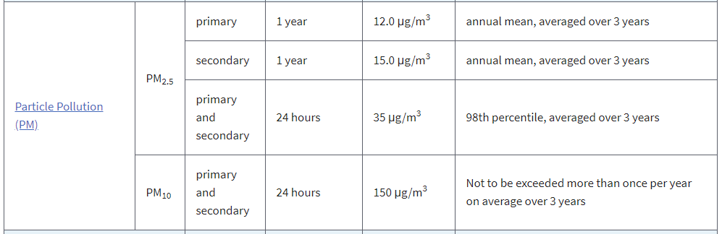

Methods of Enforcing
State owned monitors can provide real time information about particulate matter levels
“Fugitive dust is monitored as particulate matter that is smaller than 10 microns (PM10) and compared against a 24-hour standard…… Monitored PM10 values may not exceed the standard more than once per year on average over three years. This methodology means that although a single day can have an average above the standard, over three years no more than three days may exceed the standard.”
Citizen complaints
Penalties include fines or suspension of operation

Other Resources

“40 CFR Part 63 - NATIONAL EMISSION STANDARDS FOR HAZARDOUS AIR POLLUTANTS FOR SOURCE CATEGORIES,” n.d. https://www.law.cornell.edu/cfr/text/40/part-63.
“Alaksa DEC Division Of Air Quality.” Accessed February 10, 2020. https://dec.alaska.gov/air/.
“Alaska Admin Code 18 AAC 50,” n.d. http://www.akleg.gov/basis/aac.asp#18.50.
Alaska Department of Deparment of Enviromental Control. “FAQ: Air Permits and Particulate Matter.” Accessed February 9, 2020. https://dec.alaska.gov/air/air-permit/fugitive-dust/.
———. “Fugitive Dust Frequently Asked Questions,” March 31, 2011. https://dec.alaska.gov/air/air-permit/fugitive-dust/.
“Minor General Permit 9 (MG9) Application for Rock Crushers.” STATE OF ALASKA Dept. of Environmental Conservation Division of Air Quality/ Air Permits Program. Accessed February 10, 2020. https://dec.alaska.gov/air/air-permit/guidance/#nogo.
“NAAQS Table.” United States Environmental Protection Agency. Accessed February 10, 2020. https://www.epa.gov/criteria-air-pollutants/naaqs-table.

TEMPLATE
Provided as spate file.

